COMMUNITY SERVICE REQUEST MANAGEMENT SYSTEM
FOR BARANGAY SAN RAFAEL

UNIVERSITY OF LA SALETTE, INC.
COLLEGE OF INFORMATION TECHNOLOGY
PCCBSIT 006 – APPLICATION DEVELOPMENT AND EMERGING TECHNOLOGIES
ASSESSMENT A2 – APPLICATION PLANNING AND DESIGN

Prepared by:
GROUP 5
Dionisio, Joseph R.
Mariano, John Idrian
Martin, Jhade Lorenz C.
Namoc, Charles Klyde T.

BSIT 3A
Date of Submission: September 2026
Submitted to:
Sir Michael Baltazar
TABLE OF CONTENTS
1. Client Profile 2
2. Statement of the Problem 5
3. Stakeholders 7
4. Proposed Application 8
5. Application Objectives 9
6. Application Scope 9
7. Functional Requirements 11
8. Non-Functional Requirements 12
9. Application Architecture 13
10. Application Components 15
11. Data Flow 16
12. Navigation Plan 17
13. Interface / Wireframes 19
14. Technology Selection 27
15. Usability Considerations 28
16. Requirements-to-Design Traceability 29
17. Consultation and Revision – Meeting Agenda 32
18. Final Proposed Design 32
19. Conclusion 35

1. Client Profile
1.1 Organization Information
Item | Information
Organization Name | Barangay San Rafael
Organization Type | Barangay Office / local government office context
Main Services | Certificates, clearances, community assistance, complaint handling, referral services, and other resident requests requiring review or approval.
Target Users | Residents, front-desk employees, barangay secretary, barangay captain, and council members.
Available Resources | Computers, printer, basic spreadsheet and word-processing software, and internet access that is available but not always dependable.
Key Constraints | Limited funds, varying levels of computer familiarity, privacy concerns, and paper procedures that may still be required.

1.2 Current Process
Residents approach the receiving table, explain what they need, and present identification or supporting documents. Staff may provide forms for selected requests, while other concerns are recorded directly in logbooks. Completed forms are placed in folders by service type. The barangay secretary later reviews requests and determines which items need barangay captain approval, which can be processed by authorized staff, and which require additional documents.
The office maintains separate logbooks for certificates and clearances, complaints, and community assistance or referrals. Some information is also encoded into spreadsheets for periodic reporting. As a result, the same resident may appear in several records with inconsistent spellings, addresses, or contact information. Complaint follow-ups and other actions may be recorded in separate notes or personal notebooks.
1.3 Client Context and Assumptions
Barangay San Rafael is used as the client context for this student-developed system. The group will implement a simple working web application based on the supplied scenario. The design prioritizes a manageable Laravel implementation, existing office resources, privacy of resident information, and continued paper procedures where required.
For the initial implementation, the system will use two application roles: Administrator and Staff. Residents remain service beneficiaries and subjects of records, but they will not need application accounts. This keeps the system practical while addressing centralized records, request status tracking, and follow-up monitoring.

2. Statement of the Problem
2.1 Background of the Problem
Barangay San Rafael relies on a combination of paper forms, folders, multiple logbooks, spreadsheets, and individual notes to manage certificates, clearances, complaints, community assistance, referrals, and other resident requests. Because the same information can be recorded in more than one place, resident records may contain inconsistent spellings, addresses, or contact information.
The scenario also shows that pending requests and follow-up actions can be difficult to track. The secretary may keep a separate handwritten list for requests that need signatures or follow-up, while complaint actions may be stored in another notebook. When the employee who handled a case is absent, another staff member may have difficulty determining the latest status. These conditions can also make periodic reporting more labor-intensive.
2.2 Problem Statement
The primary problem is the absence of a centralized and consistent method for recording, monitoring, retrieving, and reporting barangay service requests and follow-up information that is currently distributed across multiple paper and digital records.
2.3 Effects of the Problem
- Staff may spend additional time searching folders, logbooks, spreadsheets, or separate notes.
- Residents may receive less predictable information about when their requests or documents will be ready.
- Complaint follow-up histories may be difficult to reconstruct when information is recorded in separate places.
- Reports may require manual counting or consolidation from multiple records.
- Inconsistent resident information may make record matching and retrieval more difficult.

2.4 Why an Application Could Help
A centralized application can provide authorized personnel with one organized location for recording requests, updating statuses, monitoring pending actions, retrieving records, and generating basic summaries. This directly addresses the scenario’s dependence on separate logbooks, spreadsheets, folders, and personal notes.

3. Stakeholders
Stakeholder | Role | Needs / Expectations
Residents | Submit requests, complaints, and assistance-related concerns; follow up on status. | Shorter waiting time, clearer service information, and understandable request status.
Front-Desk Employees | Receive requests and record initial information. | Simple data entry, reduced duplicate work, and easy record retrieval.
Barangay Secretary (Ms. Flores) | Reviews requests, monitors pending items, prepares reports, and tracks follow-ups. | Clear visibility of pending actions, approvals, follow-ups, and report-ready information.
Barangay Captain | Reviews and signs selected documents or cases. | Access to items requiring review or approval with relevant information.
Council Members | May request information about complaints, programs, or assistance. | Organized information and reports for authorized use.

4. Proposed Application
Item | Proposed Application
Application Name | Community Service Request Management System for Barangay San Rafael
Application Type | Proposed web-based application
Main Purpose | Centralize the recording, monitoring, retrieval, and status tracking of selected barangay service requests and related follow-up activities.
Target Users | Authorized barangay personnel (Administrator and Staff). Residents are recorded as requesters and do not have application accounts.
Problem Addressed | Fragmented records, inconsistent information, difficulty tracking pending work, and difficulty retrieving follow-up information.

4.1 Application Description
The Community Service Request Management System is a simple internal web application for Barangay San Rafael. Authorized staff can maintain a reusable resident record, create a service request, update its status, add follow-up actions, search previous transactions, and view basic monitoring reports. Certificate/clearance, complaint, and assistance/referral concerns are handled as service categories within one request workflow.
4.2 Implementation Boundary
This manuscript documents the planned and designed student-developed system that will be implemented using Laravel and MySQL. It is based on the supplied Barangay San Rafael scenario and does not claim that Barangay San Rafael has already adopted the system or that the application is an official government information system.

5. Application Objectives
- To centralize resident and service-request records so authorized personnel can retrieve information from one system.
- To provide a simple process for recording certificate/clearance, complaint, and assistance/referral concerns through one request workflow.
- To allow authorized staff to update request status and record follow-up actions in one request history.
- To provide a dashboard and basic reports that help staff monitor pending and completed requests without manually consolidating several records.
- To protect resident information through authentication and role-based access.

6. Application Scope
6.1 In Scope
- Authorized-user login and role-based access.
- Service-request intake and record creation.
- Resident/requester information management needed for request processing.
- Request status tracking and pending-action monitoring.
- Search and retrieval of request records.
- Basic reports for pending, completed, and selected transaction categories.
- Complaint recording and follow-up tracking through the same Service Request record.
- Community assistance/referral concerns recorded as Service Request categories.
6.2 Out of Scope
- Replacement of all legally or administratively required paper records.
- Full accounting, payroll, or other unrelated municipal systems.
- Purchase or management of specialized hardware.
- Guaranteed online operation during internet outages.
- Official barangay adoption, production deployment, or use of real resident records.
6.3 Scope Limitations
The Minimum Viable Product (MVP) uses a focused internal workflow: authenticated staff record a resident, create a service request, update its status, add follow-up actions, search previous records, and generate basic reports. Service categories are handled within the same transaction model to keep implementation manageable.
Digital signatures, online payments, citizen accounts, SMS/email notification infrastructure, advanced analytics, and unrelated municipal subsystems are outside the MVP because they would increase development effort without directly solving the central record-management problem.

7. Functional Requirements
Requirement ID | Functional Requirement
FR-01 | The system shall require authorized-user login and restrict actions based on role, so only permitted staff can view or edit resident/request data.
FR-02 | The system shall allow staff to create a new Service Request record, selecting a category (certificate/clearance, complaint, or community assistance/referral) within a single unified request workflow.
FR-03 | The system shall allow staff to record and manage resident/requester details needed to process a request.
FR-04 | The system shall allow authorized staff to update the status of a Service Request (e.g., Pending, In Progress, Completed).
FR-05 | The system shall allow staff to add follow-up actions or notes to a Service Request, building a single chronological history for that record — including complaint follow-up — rather than a separate log.
FR-06 | The system shall allow staff to search and filter Service Request records (e.g., by resident, category, status, date).
FR-07 | The system shall provide a dashboard giving staff an at-a-glance view of pending and completed requests without manually consolidating records.
FR-08 | The system shall generate basic reports summarizing pending, completed, and selected transaction categories.

8. Non-Functional Requirements
Quality Attribute | Non-Functional Requirement
Usability | The interface shall use clear labels, simple forms, predictable navigation, and understandable status values for staff with different levels of computer familiarity.
Performance | Common record searches and dashboard pages should return results efficiently under normal office use.
Security | Resident and complaint-related information shall require authenticated access, with administrative functions limited by role.
Reliability | The system shall validate required fields before saving and preserving successfully stored request records.
Responsiveness | The interface shall remain readable and usable on the office computer screen sizes targeted by the system.
Maintainability | The Laravel application shall separate routes, controllers, models, views, and migrations using a simple MVC structure.
Data Minimization | The system shall collect only resident and request information necessary for the defined service-request workflow.

9. Application Architecture
9.1 Architecture Diagram
Figure 1.
Blade presents the interface, controllers process requests, Eloquent represents records, and MySQL stores persistent data.
9.2 Architecture Explanation
Architecture Component | Role in the Proposed System
User Interface | Laravel Blade views with HTML/CSS provide login, dashboard, resident, request, and report screens.
Application / Business Logic | Laravel routes/controllers validate input, apply request rules, update status, and enforce roles.
Data / Model Layer | Eloquent models (e.g., Resident, Service Request) represent database records as objects, letting Controllers query and save data without writing raw SQL.
Database | MySQL stores users, residents, service requests, and request updates as persistent rows.
Security / Access Control | Enforced within Controllers via Laravel's authentication and role checks, restricting which actions and views are accessible per role.

The architecture follows a simple MVC structure because the group has beginner-level Laravel experience. This keeps views, request handling, database access, and migrations organized without introducing unnecessary framework complexity.

10. Application Components
Component / Module | Main Functions | Primary Users
Authentication and User Management | Login, logout, roles, and basic user administration. | Administrator / Staff
Resident Management | Create, update, search, and reuse resident records. | Administrator / Staff
Service Request Management | Create, view, update, search, and track requests. | Administrator / Staff
Status and Follow-up Monitoring | Update service request status and record chronological follow-up history. | Administrator / Staff
Dashboard and Reports | Pending counts, request summaries, and date/status/category filtering. | Administrator / Staff
Database | Users, residents, service requests, and request status/follow-up history. | System

11. Data Flow
11.1 Data Flow Diagram
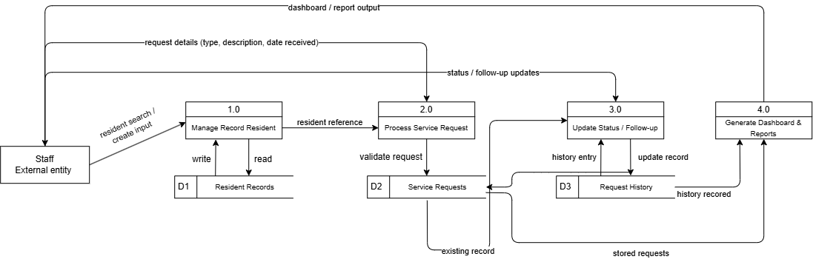
Figure 2.
Authenticated staff enter a request, Laravel validates it, MySQL stores it, and the stored record feeds status, follow-up, dashboard, and report views.
A typical transaction begins when an authenticated staff member searches for an existing resident or creates a new resident record. The staff member then creates a service request containing the service type, description, date received, and other required information. Laravel validates the input and stores the transaction in MySQL.
A typical request begins when authorized staff record a resident’s concern or service request. The application validates required information, processes the request according to the proposed workflow, and stores the resulting record in the database. When staff perform follow-up actions or change the request status, the application updates the record so authorized users can view the latest recorded information. Reports can then use stored records rather than requiring staff to manually count several separate logbooks.
When staff update the status or add a follow-up action, the system records the change in the request history. Dashboard and report screens query the stored records to show pending work and summaries. This keeps the latest recorded information with the request instead of separating it into notebooks or other files.

12. Navigation Plan
12.1 Navigation Map
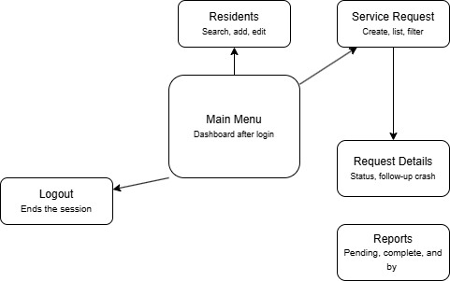
Figure 3.
The main menu keeps frequent staff tasks—residents, service requests, request details, reports, and logout—within a simple path.
After login, users enter the dashboard. From the dashboard they can maintain Residents, create or search Service Requests, open Request Details to update status or add follow-up actions, and access Reports. Administrative functions such as user management are visible only to the Administrator role.
The proposed navigation prioritizes the staff tasks that are most relevant to the scenario: locating a request, checking its current status, recording an action, and finding information for follow-up. Common functions should be reachable from the dashboard with minimal unnecessary navigation.

13. Interface / Wireframes
Screen 1 – Login
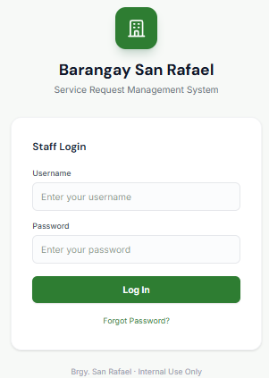
Figure 4. Staff Login Wireframe
The login screen accepts the minimum credentials needed for authenticated access that includes Username input and Password input.

Screen 2 – Dashboard
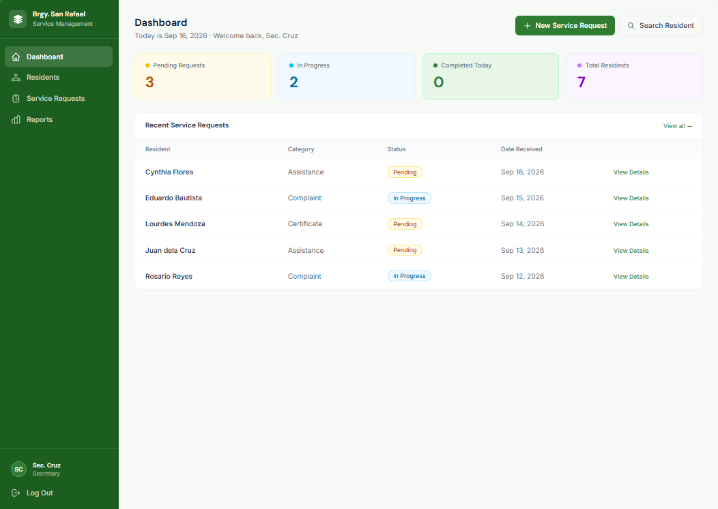
Figure 5. Dashboard Wireframe
The dashboard focuses on pending work, request counts, recent transactions, and shortcuts navigations to common tasks.

Screen 3 – Residents List
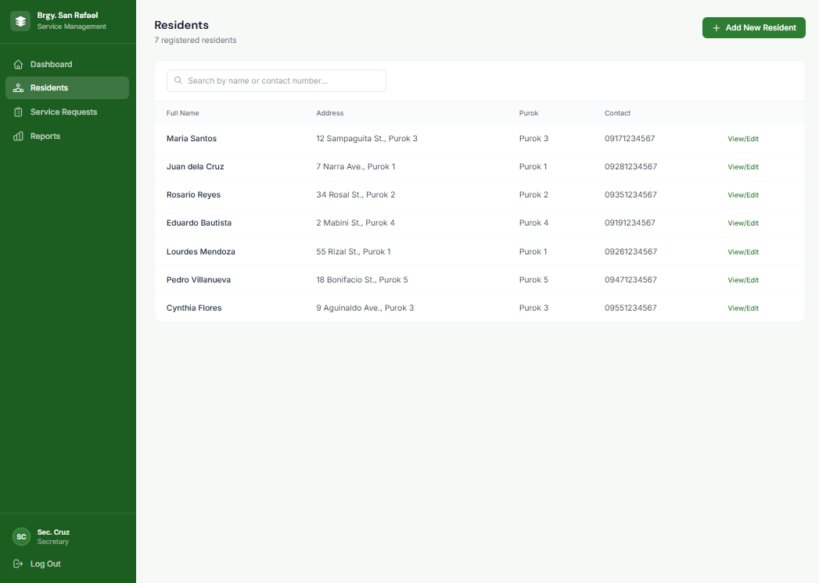
Figure 6. Residents List Wireframe
The records screen provides search and filtering so staff can find, add requests, and view request status without checking several logbooks.

Screen 4 - Add New Resident
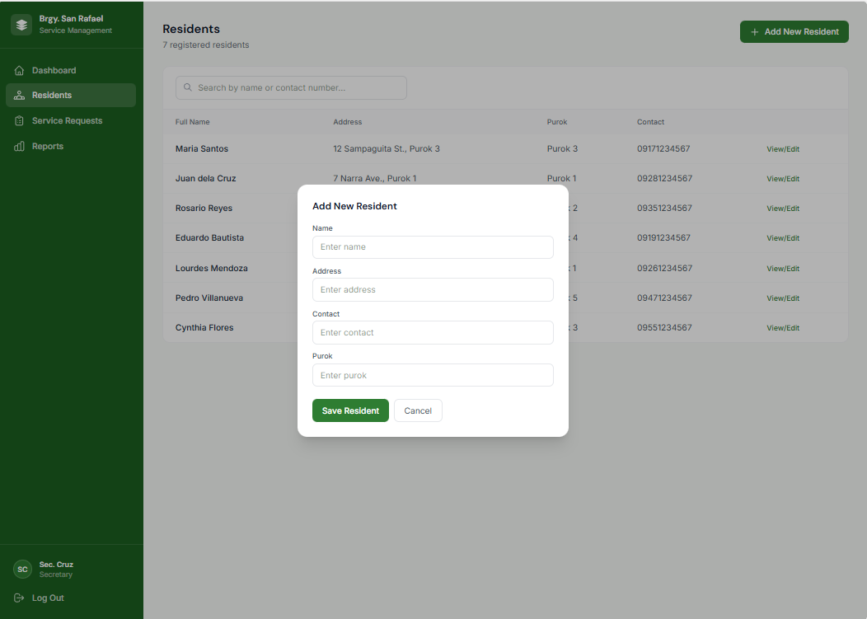
Figure 7. Add New Resident List Wireframe
The add new Resident modal Provides the input of Name, Address, Contact, and Purok of a client.

Screen 5 – Service Request
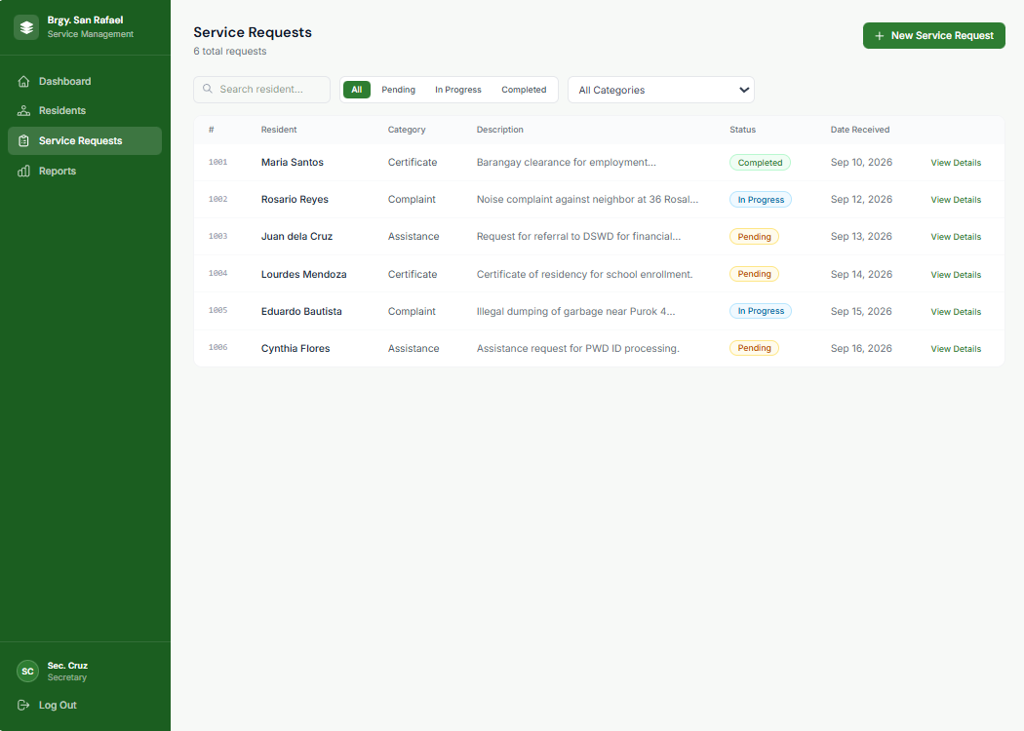
Figure 8. Service Request Wireframe
This Screen captures the resident, service category, description, document-check information(status), and date received.

Screen 6 - Add New Service Request
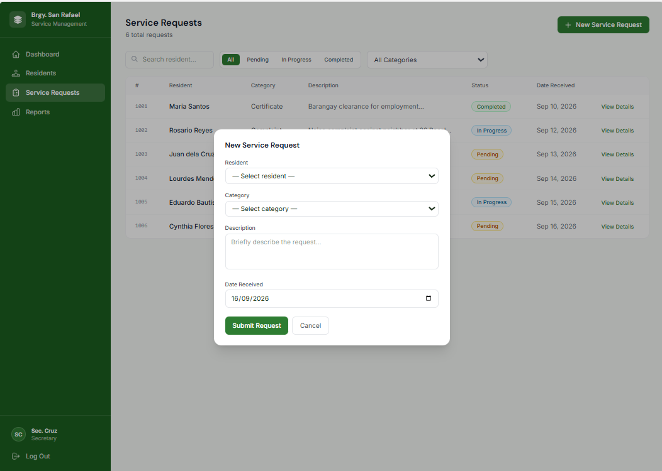
Figure 9. Add New Service Request Wireframe
The Add New Service Request Modal shows the input of resident, service category, description, document-check information(status), and date received.

Screen 7 – Reports
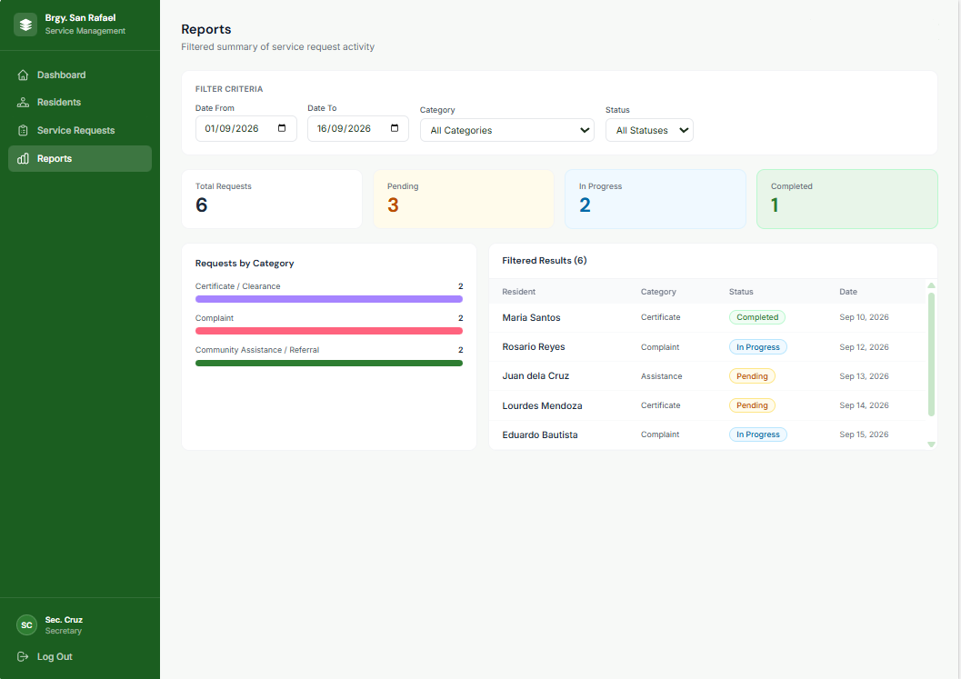
Figure 10. Report Page Wireframe
The report board presents the Filtered result of the total Request made, Pending requests, In progress Requests, and Completed Requests. The Board includes Filtering navigation for Date From, Date To, Category, and Status.

Screen 8 – Logout
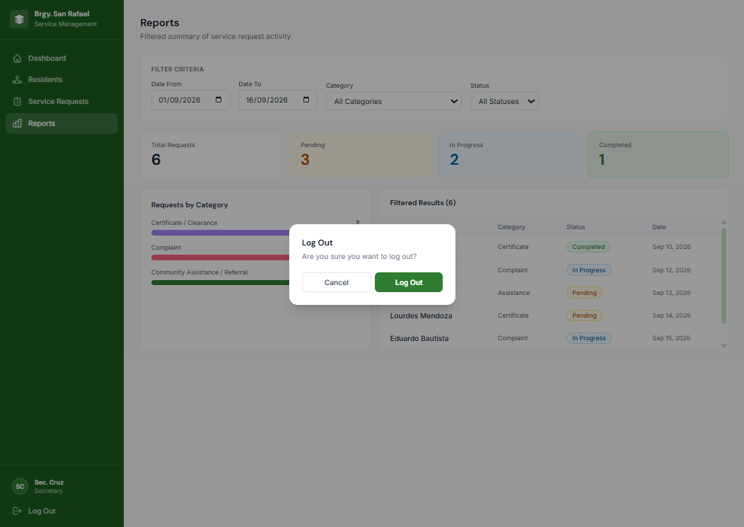
Figure 11. Staff Logout Wireframe
The Log out modal presented in every board includes its Log Out modal.

14. Technology Selection
Category | Starter Technology | Reason / Team Decision
Front-end | Laravel Blade + HTML / CSS / Javascript | Simple server-rendered pages and responsive forms without a separate SPA framework.
Back-end | Laravel (PHP) | Matches the group’s current coursework and beginner-level experience with routes, controllers, and models.
Database | MySQL | Appropriate for related users, residents, requests, and follow-up records.
IDE / Tools | Visual Studio Code + Composer + Git | Supports Laravel development, package management, and collaboration.
Development / Demonstration | Local Laravel environment; final demonstration deployment if required | Keeps development practical without unnecessary hosting complexity.

15. Usability Considerations
Usability Consideration | How It Will Be Applied
Clear button labels | Use New Request, Save Request, Update Status, Add Follow-up, Search, and Logout.
Consistent navigation | Keep Dashboard, Residents, Service Requests, Reports, and Logout in predictable locations.
Simple forms | Use only needed fields and reuse saved resident information instead of retyping it.
Error messages | Identify invalid/missing fields and explain what should be corrected.
Confirmation messages | Confirm successful saves and important status changes.
Readable text | Use clear hierarchy, readable table text, spacing, and uncluttered layouts.
Responsive interface | Use a responsive layout for different office monitor sizes.
Accessibility | Use descriptive labels and understandable status wording for non-technical users.

16. Requirements-to-Design Traceability
FR-01 – Authentication
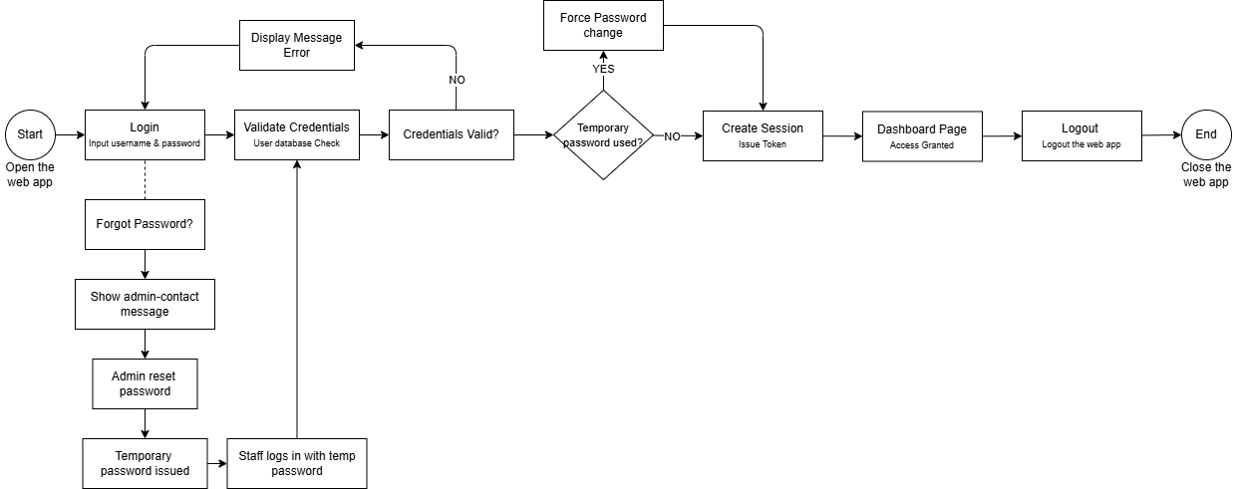
Figure 12.
Only authenticated users can access the system.

FR-02 – Service Request Creation
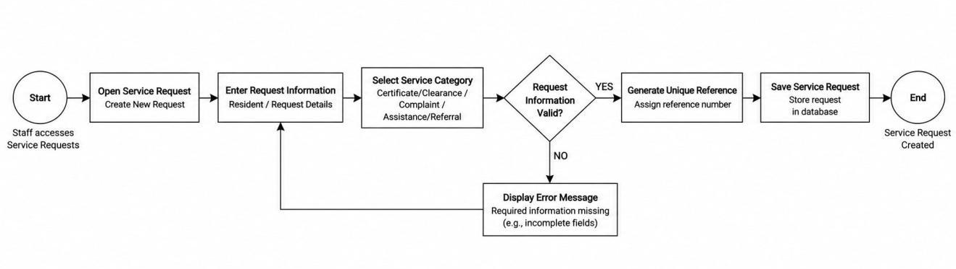
Figure 13.
A Service Request is recorded under the selected category with a unique reference.

FR-03 – Resident Management
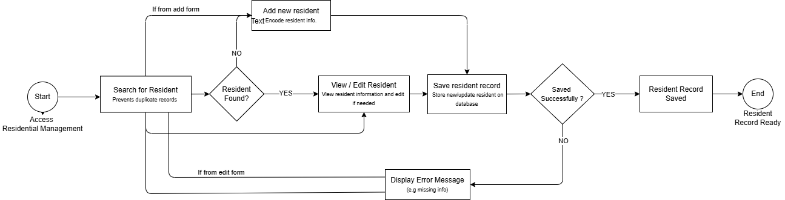Figure 14.
A reusable resident record can be maintained for future Service Requests.

FR-04 – Status Update
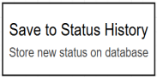
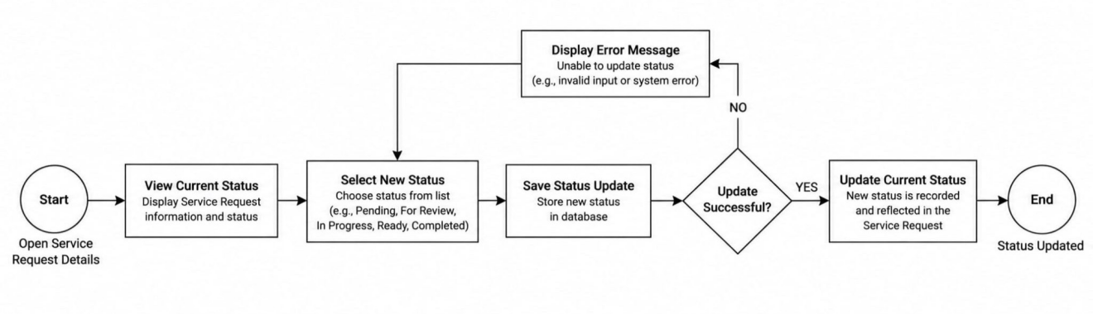
Figure 15.
The current Service Request status is recorded and can be updated by authorized staff.

FR-05 – Follow-up Management
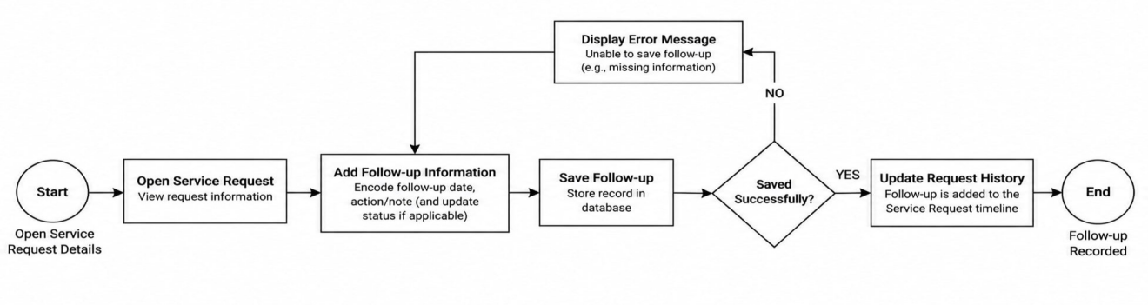
Figure 16.
Follow-up actions remain attached to the Service Request history.

FR-06 – Search / Filtering
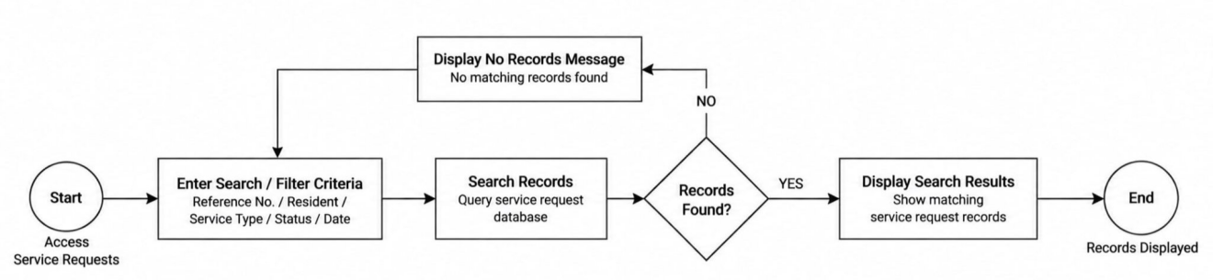
Figure 17.
Staff can locate Service Request records using search and filtering.

FR-07 – Dashboard Monitoring
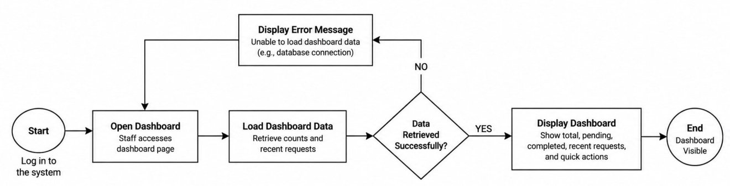
Figure 18.
Pending and completed requests are visible for staff monitoring.
FR-08 – Reports
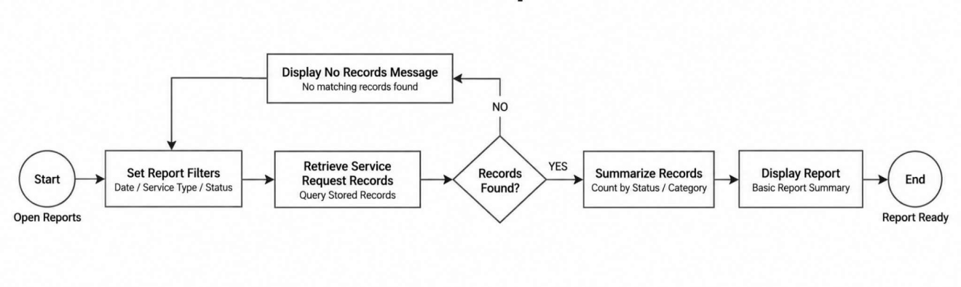
Figure 19.
Stored records support basic reports.

17. Consultation and Revision – Meeting Agenda
On 15 September 2026, project instructor Sir Michael Baltazar provided the initial scenario, document details, and project requirements, and subsequently reviewed the working draft. He requested that the client context be added, the central problem and objectives be aligned, the scope be narrowed, and the functional and non-functional requirements be supported by diagrams and descriptions, along with the corresponding architecture, data flow, navigation, and interface visuals.

18. Final Proposed Design
The project uses the supplied Barangay San Rafael scenario as its client context. The record below documents internal project-leader feedback and does not claim that an external Barangay interview occurred.
18.1 Final Design Overview
The proposed design centers on a centralized service-request record with role-based access, clear status tracking, searchable records, and basic reporting. It is intended to help authorized barangay personnel organize request information and follow-up actions while remaining realistic within the scenario’s limited resources and continued paper requirements.
18.2 Expected Benefits
- More organized retrieval of service-request information.
- Clearer visibility of pending and completed work.
- More consistent recording of request and follow-up details.
- Less dependence on searching across multiple separate records for routine lookups.
- Better support for preparing basic reports and monitoring.

18.3 Final Design Assumptions
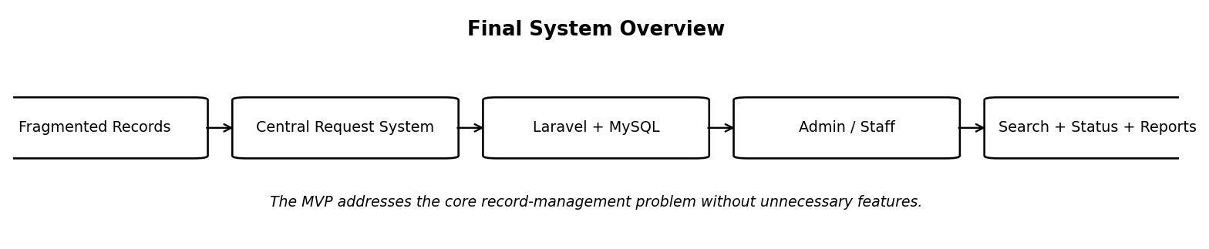
The implementation assumes access to at least one suitable computer for the Laravel application and MySQL database. Staff will receive basic orientation on login, resident records, service requests, status updates, follow-ups, and reports. The MVP does not depend on a public resident portal or external notification service.
The final design connects the manual-record problem to a manageable Laravel/MySQL system for centralized requests, tracking, and reporting.
The final system is an internal web-based Community Service Request Management System for Barangay San Rafael. It will be implemented using Laravel, Blade, HTML/CSS/Bootstrap, and MySQL. The MVP uses two application roles: Administrator and Staff. Residents are recorded as requesters rather than maintaining system accounts.
The core transaction is the Service Request. It stores the requester, service type, description, date received, status, and follow-up history. Certificate/clearance, complaint, and assistance/referral concerns are represented as service categories within the same workflow, avoiding separate complex subsystems.
Official signatures and paper documentation remain outside the digital workflow where required. The system records processing status and follow-up information for monitoring while excluding digital signatures, online payments, advanced analytics, and unrelated systems from the MVP.

19. Conclusion
The Community Service Request Management System for Barangay San Rafael is designed to address fragmented logbooks and spreadsheets, inconsistent resident information, difficulty locating requests, separated follow-up notes, and manual reporting. The Laravel and MySQL implementation centralizes resident and request records while providing status tracking, follow-up history, search, dashboard monitoring, and basic reports. Its focused scope is intentional so the group can realistically implement and demonstrate the core system while considering privacy, usability, limited resources, and procedures that still require paper documentation.

